ASCII Rasterizer
Tenix7676

Opis projektu
Rendering 3D wireframes and drawing lines using ASCII characters.

Funkcjonalności

Vector.h
Library implements 2D and 3Dvectors and basic operations such as addition, scaling, length, dot product, and cross product.

Screen.h
Drawing characters to the console:
reset() clears the screen,
print() displays the screen,
draw() draws a point on the screen,
drawLine() draws a line between two points, implemented in DrawLineASCII.h,
drawLineHorizontal(), drawLineVertical() draw horizontal and vertical lines respectively (implemented in DrawLineASCII.h)
writeStringOneLine() writes text at x0, y0
writeStringOneLineCentered() centers text around x0, y0

Fraction.h

Implements a fraction as two integers and basic fraction operations: addition, subtraction, multiplication, division, and comparison.

Slope.h
Data required for DrawLineASCII.h.

DrawLineASCII.h

Draws a line from point x0, y0 to x1, y1 (as well as horizontal and vertical lines).

Menu.h i Input.h

Implementation of the menu and user input.

Rasterizer.h
getScreenX() and getScreenY() convertion from a 3D point to screen coordinates
The wireframe class allows creation of shapes made from lines (currently only a cube has a generating method).

Przebieg realizacji

Rasterizer.h
The implementation of getScreenX() and getScreenY() is well explained in the book:
https://gabrielgambetta.com/computer-graphics-from-scratch/09-perspective-projection.html
However, note that in this program, the Z-axis is the height, while in the book it's the Y-axis.
Using the cube example, wires contains the unrotated cube centered at (0,0,0). The getWiresToDraw() function uses getRealPos(), which rotates and moves each point pair to the real place in the coordinate system, based on Wireframe::center.
(*Unless Wireframe::turnX(), turnY(), or turnZ() are used, which actually modify the point pairs in Wireframe::wires.)

Slope.h
SlopeEnum lists all hard-coded slope patterns.
fractions[]: array of fractions representing line slopes (denominator = Δx, numerator = Δy).
patterns[]: encodes the ASCII pattern for each slope.
For exammple slope 1/1 would like like this on screen:
\
\
\
\
And in code:
{'\\',NULL,NULL,
NULL,NULL,NULL,
NULL,NULL,NULL}

Slope 1/3 on screen:
`*.
`*.
`*.
1/3 in code:
{'`','*','.',
NULL,NULL,NULL,
NULL,NULL,NULL}

Slope 2/3 on screen:
`,
.
`,
.
2/3 in code:
{'\'',',',NULL,
NULL,NULL,'.',
NULL,NULL,NULL}

It’s not too difficult to add custom patterns, update three arrays and possibly adjust SLOPE_1_GREATER_THAN_4 and SLOPE_GREATER_THAN_4_1 in DrawLineASCII.cpp.

DrawLineASCII.h
Drawing lines that match hardcoded slopes are handled by drawSlopeOnce(), which reads and renders the encoded pattern. drawSlopeFull() repeats the pattern as needed
For example drawLine(0, 0, 30, 10) will draw SLOPE_1_3, repeated 10 times
`*. once
`*. twice
`*. thrice
`*. four
`*. five
`*. six
`*. seven
`*. eight
`*. nine
`*. ten times
What’s interesting in this function is the fact that it automatically reverses the pattern for upward lines, switches ‘\’ for ‘/’.
Let’s consider drawLine(0, 0, 33, 10)
Our slope rounds is about 33/10 ~ 3/1
So we will use the 3/1 pattern. But if we used this pattern we would be missing 3 units from our destination (33 – 30 = 3) (left_over_x = 3).
So we cut our line into (3+1) segments, so we have 3 splits where we can put `, shown in green.
`*.
`*.
``*.
`*.
`*.
``*.
`*.
``*.
`*.
`*.
Squeezing these 3 ` allowed us to horizontally elongate the line, so we made it to our destination.
Example drawLine(0, 0, 34, 10), left_over_x = 4
`*.
`*.
``*.
`*.
``*.
`*.
``*.
`*.
``*.
`*.
In some sense, the program cannot draw elements smaller than the hardcoded patterns (here “`*.”), so what happens when the program rounds the slope to 1/3, but we have to make more than 9 segments?

Example drawSlopeFull(SLOPE_1_3, 0, 0, 41, 10) – force the program to use SLOPE_1_3
*.
``*.
``*.
``*.
``*.
`*`*.
``*.
``*.
``*.
``*.
This is the the result on the screen^ in the middle two characters are inserted `*. The algorithm works like this:
If left_over_x < 10, Cut into (left_over_x + 1) segments
and in each split call drawLineHorizontalSloped()
If left_over_x >= 10, Cut the line into (10)
and in each split call drawLineHorizontalSloped()
drawLineHorizontalSloped(L) draws a line of a length L that goes down (or up), e.g.:
L = 10: ````***...
L = 6: ``**..
^For patterns where dy=1 the program acts differently, to make it look prettier:
*.
``*.
``*.
``*.
``*.
``**.
``*.
``*.
``*.
``*.
The middle insert (L=2) and pattern (of length 3) become one line of L = 2 + 3 = 5
In other words we use drawLineHorizontalSloped(), instead of drawLineHorizontalSloped() and drawSlopeOnce()
Appropriately, when the line does not reach the point on the y-axis, we have left_over_y, and we also divide the line into left_over_y + 1 segments.
It is sometimes necessary to cut up the line into segments in both x and y. That is also handled.
For example left_over_x = 3, left_over_y = 1 i SLOPE_1_3 (In reality this would never happen,
33 x i 11 y, so we would just use SLOPE_1_3);
`*.
`*.
``*.
`*.
`*.
|
``*.
`*.
``*.
`*.
What if after segementation we have to connect to connect a hole with dimensions 2y i 3x:
`*.
`*.
The program will draw:
`*.
'
`*.
`*.
But it should draw, the known SLOPE_2_3:
`*.
',
.
`*.
How to solve this? Recursion can be used, where at the start a recursive version of the function drawLine() is run, which calls the function drawLineNoRecursion() between the breakpoints of the line. The drawLineNoRecursion() is just the current version of drawLine(). This way, you don’t have to handle this^ case separately. I haven’t implemented this idea yet.

User Instructions
Navigate the menu using WASD or arrow keys, and Enter.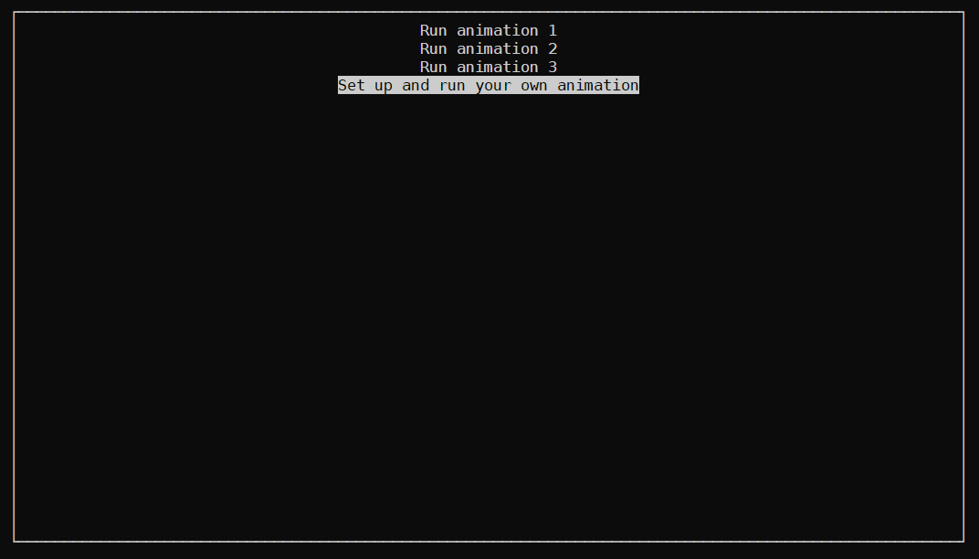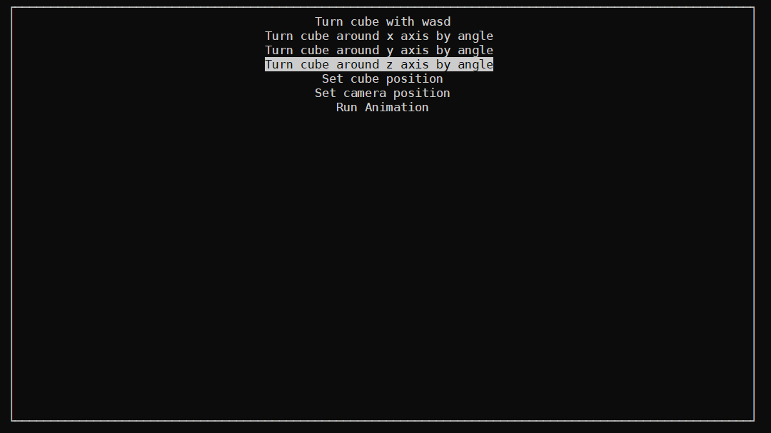

Generated cube example:
&`**.
..**` ``*.
..**` | ``**.
..**`` | ``**.
..**` | ``*.
&.**`` | ``*.
`. `*. | &
| ' | .*`
' ``*. | .*` /
`| `*. | .*` /
`. `*. | . /
| ' &`*. .*` /
' ``*. .*` ``*. ..*` .
| ..*` `.*` /
`. ..*` `*. . ``*. /
| ..*` `*. .*` `*. /
&.*` &*` &
`. . .`
`. | .`
`. | .`
`. | .`
`. | .`
`. . .
`. | .`
`. | .`
`.| .`
To add a new slope to the DrawLineASCII library, for example 1/4:
`-._
The user must update:
1. MAX_DX, MAX_DY
2. SlopeEnum
3. fractions[] in slope.cpp
4. patterns in slope.cpp

Add SLOPE_1_3 somewhere lower down in SlopeEnum:

enum SlopeEnum : short { //Hard coded slopes: //WARNING! this enum and fractions should contain at least 2 elements, otherwise the program will go out of array bounds //widest and highest slopes first, (must match Slope::MAX_DX and Slope::MAX_DY)
SLOPE_WIDE,//<-this becomes SLOPE_1_4
SLOPE_HIGH,//this must match HIGHEST_SLOPE_DY
SLOPE_1_3 //<-added SLOPE_1_3
SLOPE_1_1,
SLOPE_1_2,
SLOPE_2_3,
SLOPE_3_2,
//wider and higher slopes, edit accordingly to the widest and highest slopes, with a number +1
//so if the widest slope is SLOPE_1_5 then SLOPE_1_GREATER_THAN_6 ends in a 6
SLOPE_WIDER,
SLOPE_HIGHER,
MAX_SLOPE_FRACTIONS,
//Special slopes, don't touch these
SLOPE_1_0,
SLOPE_0_1,
MAX_SLOPES
};

Then update fractions[] and patterns[]
namespace Slope
{
const int WIDER_SLOPE_DX{ 4 }; //<- change 3 to 4
const int HIGHER_SLOPE_DY{ 2 };
const int MAX_DY{ 3 };
const int MAX_DX{ 4 }; //<- update MAX_DX
extern const Fraction fractions[MAX_SLOPE_FRACTIONS];
extern const char patterns[MAX_SLOPE_FRACTIONS][MAX_DY][MAX_DX];
}
const Fraction Slope::fractions[MAX_SLOPE_FRACTIONS] = {
//widest and highest slopes first
{ 1, WIDEST_SLOPE_DX }, // SLOPE_1_4
{ HIGHEST_SLOPE_DY, 1 }, // SLOPE_2_1
{ 1, 3 }, //<- add the same thing! // SLOPE_1_3
{ 1, 1 }, // SLOPE_1_1
{ 1, 2 }, // SLOPE_1_2
{ 2, 3 }, // SLOPE_2_3
{ 3, 2 }, // SLOPE_3_2
{ 1, WIDER_SLOPE_DX + 1 }, // SLOPE_WIDEST
{ HIGHER_SLOPE_DY + 1, 1 } // SLOPE_GREATER_THAN_3_1
};
const char Slope::patterns[MAX_SLOPE_FRACTIONS][MAX_DY][MAX_DX] =
{ //widest and highest slopes first
//WIDER (SLOPE_1_4)
{'`','-','.','_',
NULL,NULL,NULL, NULL,
NULL,NULL,NULL, NULL},
//UWAGA, places without NULL initialiaze to NULL anyway, so it’s not necessary to add NULLs everywhere
//HIGHER (SLOPE_2_1)
{'|',NULL,NULL,
''',NULL,NULL,
NULL,NULL,NULL},
//SLOPE_1_3 //<- put SLOPE_1_3 in the same spot/ index as in SlopeEnum
{'`','*','.',
NULL,NULL,NULL,
NULL,NULL,NULL},
//SLOPE_1_1
{'\',NULL,NULL,
NULL,NULL,NULL,
NULL,NULL,NULL},
//SLOPE_1_2
{'','.', NULL,
NULL,NULL,NULL,
NULL,NULL,NULL},
//SLOPE_2_3
{'\'',',',NULL,
NULL,NULL,'.',
NULL,NULL,NULL},
//SLOPE_3_2
{'|',NULL,NULL,
'`','.',NULL,
NULL,'|',NULL},
};
Summary and Conclusions
The inspiration for the project came from experimenting with ASCII art, following the tutorial at https://stonestoryrpg.com/ascii_tutorial.html. The brainstorming phase lasted quite a while, approximately a month. The first commit was on Wednesday, January 15th, 2025, at 07:04:00, and the latest one was February 4th, as I'm still adding improvements, meaning the project took about a month. The most challenging aspect of the project was creating an algorithm capable of generating a line from ASCII characters using given patterns, for any two points—not just those that form lines with slopes perfectly matching the hardcoded ones (in Slope.h, Slope.cpp). Another difficulty was implementing 3D rotations.
The program could be extended to support additional shapes and more drawing patterns. It would also benefit from improving the display capabilities, especially to support color, and from refining the somewhat hastily written code responsible for distinguishing text in normal and inverted colors. This was my first project that effectively used header files and namespaces.

